Remote Viewing within a High Voltage Apparatus

Blake Bagley, Julia Garcia, Erica Mathew

**Functional System Requirements**

REVISION – Draft

24 September 2024

Functional System Requirements

for

Remote Viewing within a High Voltage Apparatus

Prepared by:

_____________________________

Author Date

Approved by:

_____________________________

Project Leader Date

_____________________________

John Lusher, P.E. Date

_____________________________

T/A Date

**Change Record**

| **Rev.** | **Date** | **Originator** | **Approvals** | **Description** |
| --- | --- | --- | --- | --- |
| **-** | 9/26/2024 | Remote Viewing within High Voltage Apparatus |  | Draft Release |

**Table of Contents**

**Table of Contents III**

**List of Tables IV**

**No table of figures entries found. IV**

**List of Figures V**

**1.** **Introduction 5**

1.1. Purpose and Scope 5

1.2. Responsibility and Change Authority 6

**2.** **Applicable and Reference Documents** 8

2.1. Applicable Documents 8

2.2. Reference Documents 8

2.3. Order of Precedence 9

**3.** **Requirements** 9

3.1. System Definition 9

3.2. Characteristics 10

3.2.1. Functional / Performance Requirements 10

3.2.2. Physical Characteristics 10

3.2.3. Electrical Characteristics 12

3.2.4. Environmental Requirements 13

3.2.5. Failure Propagation 13

**4.** **Support Requirements 13**

**List of Tables**

Table 1: Responsibilities ……………..……………………………………………………………..6

Table 2: Applicable Documents …………..………………………………………………………..8

Table 1: Reference Documents ………………………………..…………………………………..8

**List of Figures**

Figure 1. Conceptual Image……………………………………………………………………...6

Figure 2. Block Diagram of System…………………………………………………………..9

# 

# Introduction

## Purpose and Scope

As industry demand grows, space inside medium voltage switchgear has become increasingly limited. Manufacturers are required to fit more devices and wires within the same limited space. Additionally, manufacturers are now being asked to include a remote viewing system within the switchgear to monitor a physical ground switch. This ground switch is physically blocked, by wires, from the view of the operator. Our project, *Thermal Remote Viewing System within High Voltage*, provides a real time visual depiction of the ground switch that an operator can view from a safe distance away from the switchgear. We will use a thermal sensor to create an image of the ground switch, which will then be sent to the microcontroller to process the information into a viewable format. The video information will then be sent to a web application for the operator to interface with. Our system will increase safety and efficiency for switchgear operators.

**Figure 1. Conceptual Image**

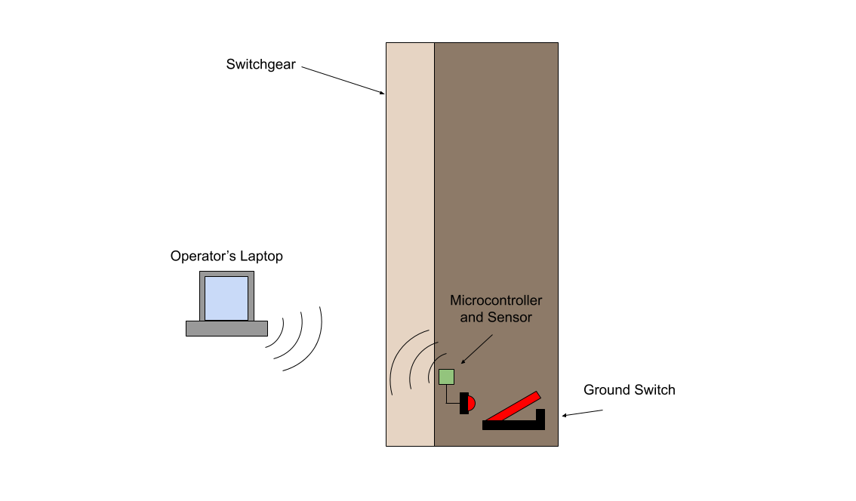

## Responsibility and Change Authority

Erica Mathew will make sure all requirements detailed in the Functional System Requirements will be met. Requirements can only be changed if Erica and our sponsors at Powell Industries approve of the changes. Below are the responsibilities of everyone in the team.

| **Subsystem** | **Responsibility** |
| --- | --- |
| Thermal Image Sensor | Julia Garcia |
| Microcontroller | Blake Bagley |
| Web Application | Erica Mathew |

# Applicable and Reference Documents

## Applicable Documents

The following documents, of the exact issue and revision shown, form a part of this specification to the extent specified herein:

| **Document Number** | **Revision/Release Date** | **Document Title** |
| --- | --- | --- |
| IEEE Standard C37.20.2 | 2015-09-22 | IEEE Standard for Metal-Clad Switchgear |
| IEEE Standard C37.04 | 2019-05-31 | IEEE Standard for Ratings and Requirement for AC High- Voltage Circuit Breakers with a Rated Maximum Voltage Above 1000V |
| IEEE Standard C37.09 | 2019-04-11 | IEEE Standard Test Procedures for AC High-Voltage Circuit Breakers with Rated Maximum Voltage Above 1000 V |
| ANSI C37.54 | 2023 | American National Standard for Alternating Current High-Voltage Circuit Breakers Applied in Metal-Enclosed Switchgear—Conformance Test Procedures |
| NFPA 70E | 2024 | Standard for Electrical Safety in the Workplace |
| NFPA 70 | 2023 | National Electrical Code |

## Reference Documents

The following documents are reference documents utilized in the development of this specification. These documents do not form a part of this specification and are not controlled by their reference herein.

| **Document Number** | **Revision/Release Date** | **Document Title** |
| --- | --- | --- |
| 1 | Version 1.9 | ESP32-S3 Series Datasheet |
| 2 | Revision 204 | FLIR LEPTON® Engineering Datasheet |
| 3 | 12/22/2020 | GlobTek, Inc. Li-Ion Polymer 3.7 V Battery Pack |

## Order of Precedence

In the event of a conflict between the text of this specification and an applicable document cited herein, the text of this specification takes precedence without any exceptions.

All specifications, standards, exhibits, drawings or other documents that are invoked as “applicable” in this specification are incorporated as cited. All documents that are referred to within an applicable report are considered to be for guidance and information only, except ICDs that have their relevant documents considered to be incorporated as cited.

# Requirements

## System Definition

The Thermal Remote Viewing System within High Voltage is a system specifically designed for remotely monitoring ground switches within a medium voltage switchgear. It allows operators to confirm a vertical tower is properly grounded before opening the switchgear. This system provides a real-time video stream of the ground switches which will be broadcasted to an online website. Our system consists of a thermal image sensor, microcontroller and a website.

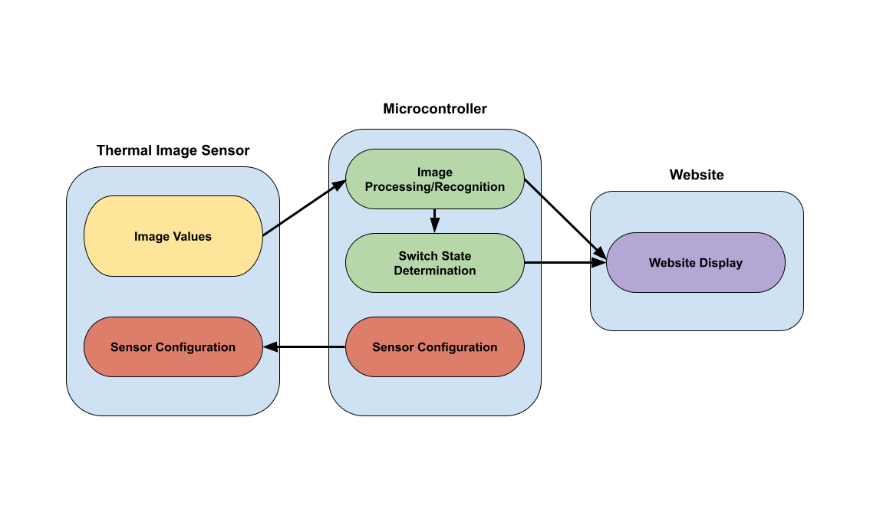

**Figure 2. Block Diagram of System**

There are three main components to this system. First block represents the first main component which is the thermal image sensor. This sensor will take in IR values and turn them into an image for the microcontroller to process. This sensor will need to be configured to be in the image format that will be used by the microcontroller.

The second block which is the microcontroller will use a machine learning algorithm to determine where the switch is located and another algorithm will be used for determining if the grounding switch is open or closed. The video and switch state will be then sent from the microcontroller to the website to be viewed by the operator.

## Characteristics

### Functional / Performance Requirements

#### Connection to Website

The Thermal Remote Viewing System shall allow for multiple microcontrollers and thermal image sensors in different vertical towers to be connected to the website.

*Rationale: This will allow for the operator to view multiple vertical towers.*

#### Machine Learning Error Rate

The Image Recognition and Switch State Determination done by the microcontroller shall not have an error rate exceeding 10%.

*Rationale: This will allow for the machine learning of the microcontroller to perform as accurately as needed.*

#### Thermal Sensor Node Area

The thermal sensors should take a visual image that covers a minimum viewable area of 6x6 inches.

*Rationale: This is a requirement specified by our customer to properly see the gap between contacts in the ground switches.*

#### Video Latency

The video output shall be a live video stream with no more than a 5 second delay.

*Rationale: This is a requirement specified by our customer to properly view the gap between contacts in the ground switches.*

#### Video Resolution

The video output shall have a pixel resolution of 160x120 pixels

*Rationale: This is the resolution of the thermal sensor we chose. This will allow for a clear image for the operator to observe.*

### Physical Characteristics

#### Volume Envelope

The volume envelope of the Remote System shall be less than or equal to 6 inches in height, 6 inches in width, and 6 inches in length.

*Rationale: This is a requirement specified by our customer due to constraints of the switchgear the system will be operating in*

#### Mounting

The thermal sensor should be mounted facing the ground switches to allow for a complete view. The mounting information shall be captured in the Remote Viewing System within High Voltage ICD.

*Rationale: This is a requirement specified by our customer to provide a clear image to the operator.*

#### Installation

The installation information for The Thermal Remote Viewing System within High Voltage shall be provided to the customer through a user manual.

### Electrical Characteristics

#### Inputs

1. No inputs of the operator shall inhibit the function of The Thermal Remote Viewing System.

*Rationale: By design, this should limit the risk of the system becoming damaged.*

##### Power Consumption

1. The maximum peak power of the system shall not exceed 3 watts.
2. For our class demonstration we will use a battery pack to power our system. If this system were to be adopted into a switchgear, it shall pull power from the switchgear itself.

*Rationale: This is specified by the ESP32-S3 Series Datasheet and FLIR LEPTON® Engineering Datasheet.*

##### Input Voltage Level

The input voltage level for the Search and Rescue System shall be +3.7 VDC to +4.2 VDC.

*Rationale: This is specified by GlobTek, Inc. Li-Ion Polymer 3.7 V Battery Pack Datasheet*

#### Outputs

##### Data Output

The Thermal Remote Viewing System within High Voltage shall include an website interface compatible with the microcontroller to view the ground switch.

*Rationale: The Thermal Remote Viewing System within High Voltage information passes directly to the customer’s system.*

##### Raw Video Output

The Thermal Remote Viewing System shall output a RAW14 video for the operator to view on the system’s website.

*Rationale: This is a requirement specified in the FLIR LEPTON® Engineering Datasheet.*

#### Connectors

The Thermal Remote Viewing System within High Voltage shall follow the America National Standard for Electrical Connectors ANSI C119.6-2011.

*Rationale: This is a requirement specified by in accordance with our battery*

### Environmental Requirements

The Thermal Remote Viewing System shall be designed to withstand and operate in the environments and laboratory tests specified in the following section.

*Rationale: This is a requirement specified by our customer due to constraints of their system in which the The Thermal Remote Viewing System is integrating.*

##### Thermal Resistance

The Thermal Remote Viewing System should be able to properly operate in an environmental temperature up to 80C.

*Rationale: This is a requirement specified in the FLIR LEPTON® Engineering Datasheet.*

##### Dielectrics Test

The Thermal Remote Viewing System shall not compromise the integrity of the dielectrics already within the switchgear

### Failure Propagation

If the website doesn’t receive video input from the microcontroller after 30 seconds, the website shall display a notice that there is a problem connecting to the microcontroller.

*Rationale: This will allow for the user to know if something is wrong with the system.*

# Support Requirements

The Thermal Remote Viewing System shall require internet connection and a computer in order to interact with the website application.